EXERCISE 9.1

Question 1:

A circus artist is climbing a 20 m long rope, which is tightly stretched and tied from the top of a vertical pole to the ground. Find the height of the pole, if the angle made by the rope with the ground level is 30°.

Solution:

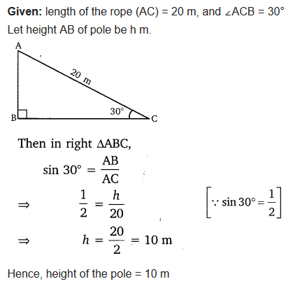

Question 2:

A tree breaks due to storm and the broken part bends so that the top of the tree touches the ground making an angle 30° with it. The distance between the foot of the tree to the point where the top touches the ground is 8 m. Find the height of the tree.

Solution:

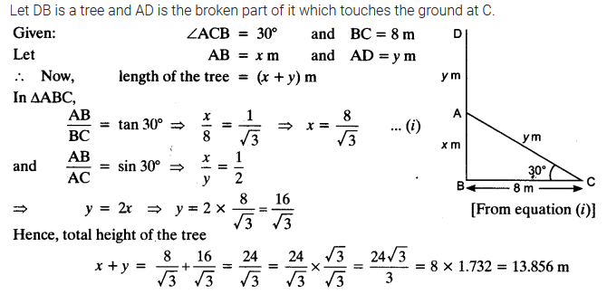

Question 3:

A contractor plans to install two slides for the children to play in a park. For the children below the age of 5 years, she prefers to have a slide whose top is at a height of 1.5 m, and is inclined at an angle of 30° to the ground, whereas for elder children, she wants to have a steep slide at a height of 3 m, and inclined at an angle of 60° to the ground. What should be the length of the slide in each case?

Solution:

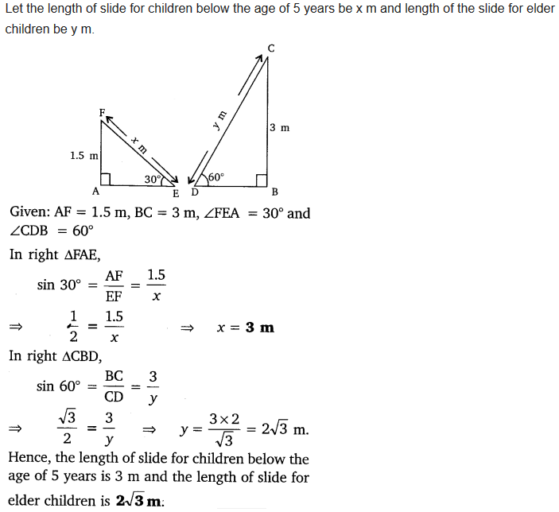

Question 4:

The angle of elevation of the top of a tower from a point on the ground, which is 30 m away from the foot of the tower is 30°. Find the height of the tower.

Solution:

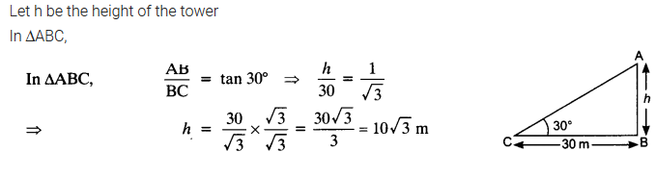

Question 5:

A kite is flying at a height of 60 m above the ground. The string attached to the kite is temporarily tied to a point on the ground. The inclination of the string with the ground is 60°. Find the length of the string, assuming that there is no slack in the string.

Solution:

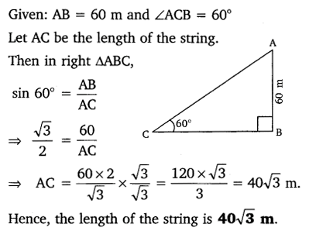

Question 6:

A 1.5 m tall boy is standing at some distance from a 30 m tall building. The angle of elevation from his eyes to the top of the building increases from 30° to 60° as he walks towards the building. Find the distance he walked towards the building.

Solution:

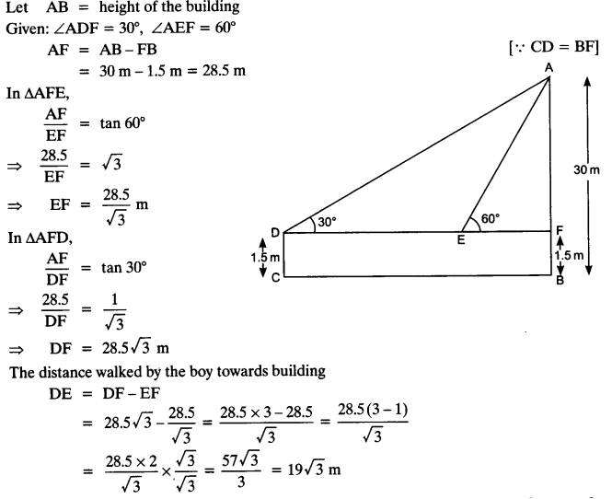

Question 7:

From a point on the ground, the angles of elevation of the bottom and the top of a transmission tower fixed at the top of a 20 m high building are 45° and 60° respectively. Find the height of the tower.

Solution:

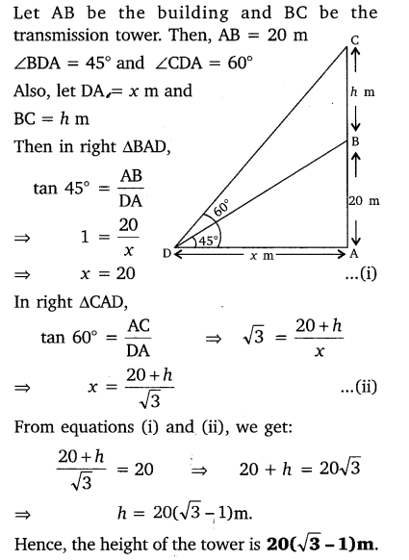

Question 8:

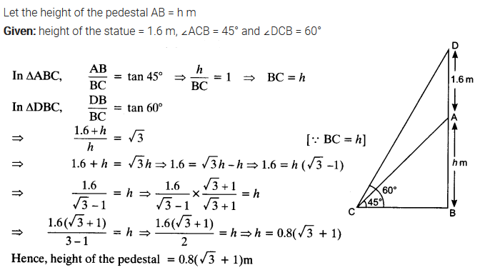A statue, 1.6 m tall, stands on the top of a pedestal. From a point on the ground, the angle of elevation of the top of the statue is 60° and from the same point the angle of elevation of the top of the pedestal is 45°. Find the height of the pedestal.

Solution:

Question 9:

The angle of elevation of the top of a building from the foot of a tower is 30° and the angle of elevation of the top of the tower from the foot of the building is 60°. If the tower is 50 m high, find the height of the building.

Solution:

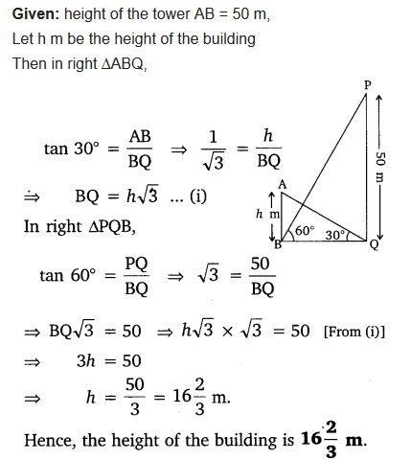

Question 10:

Two poles of equal heights are standing opposite each other on either side of the road, which is 80 m wide. From a point between them on the road, the angles of elevation of the top of the poles are 60° and 30° respectively. Find the height of the poles and the distance of the point from the poles.

Solution:

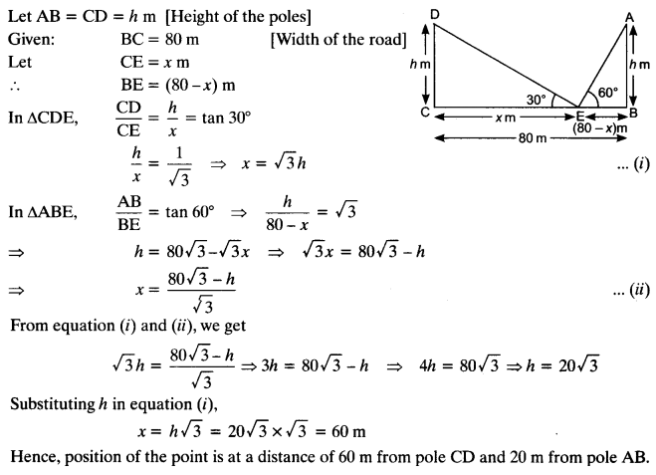

Question 11:

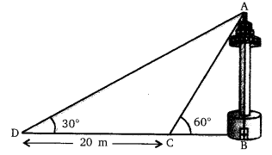A TV tower stands vertically on a bank of a canal. From a point on the other bank directly opposite the tower, the angle of elevation of the top of the tower is 60°. From another point 20 m away from this point on the line joining this point to the foot of the tower, the angle of elevation of the top of the tower is 30° (see the given figure). Find the height of the tower and the width of the CD and 20 m from pole AB.

Solution:

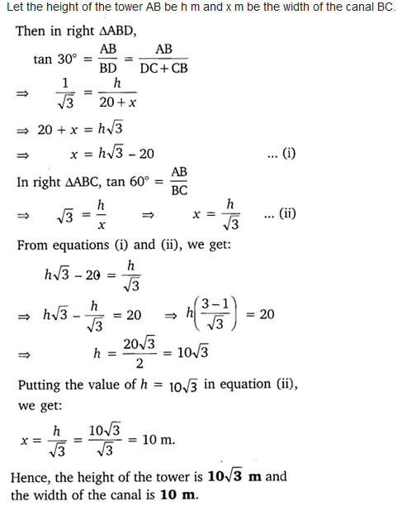

Question 12:

From the top of a 7 m high building, the angle of elevation of the top of a cable tower is 60° and the angle of depression of its foot is 45°. Determine the height of the tower.

Solution:

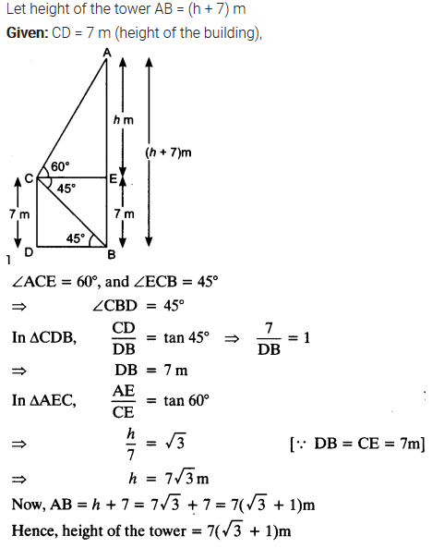

Question 13:

As observed from the top of a 75 m high lighthouse from the sea-level, the angles of depression of two ships are 30° and 45°. If one ship is exactly behind the other on the same side of the lighthouse, find the distance between the two ships.

Solution:

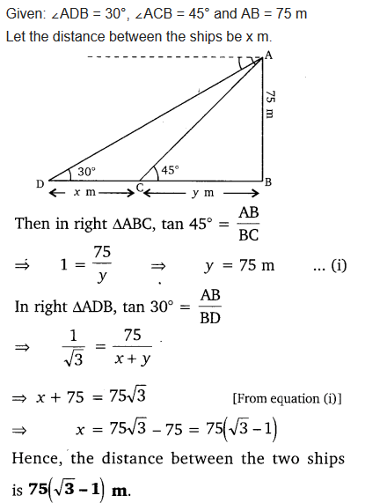

Question 14:

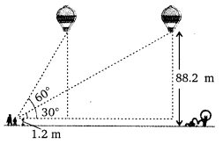A 1.2 m tall girl spots a balloon moving with the wind in a horizontal line at a height of 88.2 m from the ground. The angle of elevation of the balloon from the eyes of the girl at any instant is 60°. After sometime, the angle of elevation reduces to 30° (see figure). Find the distance travelled by the balloon during the interval.

Solution:

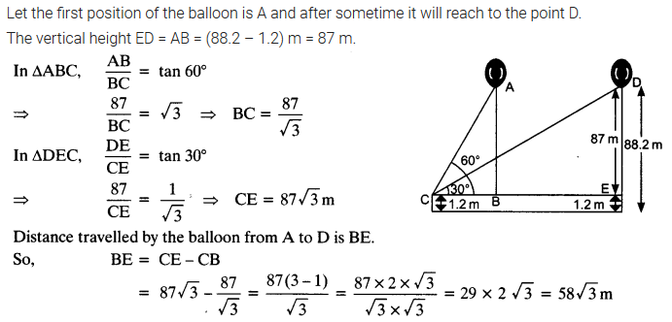

Question 15:

A straight highway leads to the foot of a tower. A man standing at the top of the tower observes a car at an angle of depression of 30°, which is approaching the foot of the tower with a uniform speed. Six seconds later, the angle of depression of the car is found to be 60°. Find the time taken by the car to reach the foot of the tower from this point.

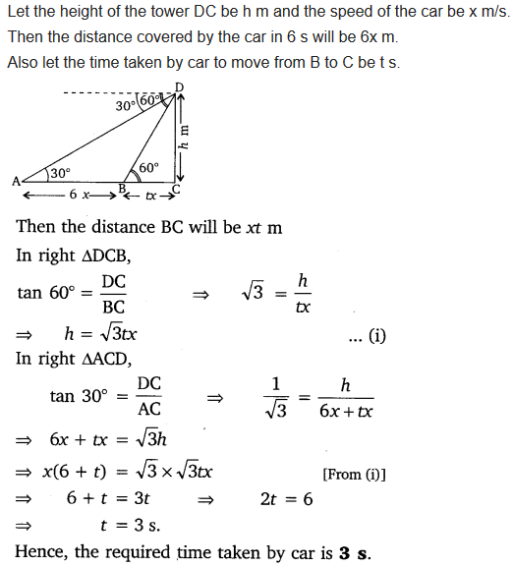Solution:

Question 16:

The angles of elevation of the top of a tower from two points at a distance of 4 m and 9 m from the base of the tower and in the same straight line with it are complementary. Prove that the height of the tower is 6 m.

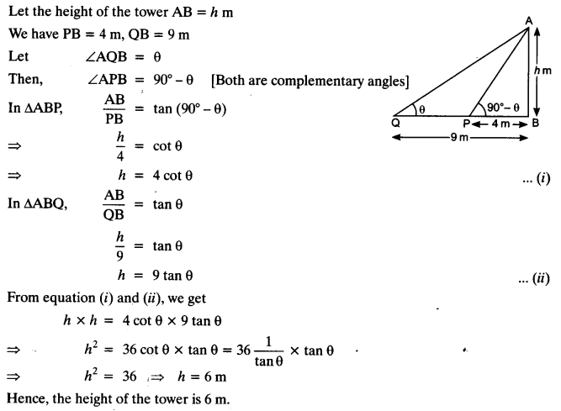Solution: